**BIG MOUNTAIN RESORT CAPSTONE PROJECT**

Big Mountain Resort, despite its facilities being among the top in the skiing resort market was not able to maximize revenue through ticket pricing. The main reason accounting for the revenue shortfall was the ticket pricing strategy which did not take into consideration the facilities, but focused on only the average price of resorts in its market segment. To avert this problem, it was necessary to build a predictive model for the ticket price based on the facilities owned by resorts in the market. The model was to provide guidance for Big Mountain Resort to set a better ticket price and change its investment strategy in the future.

After comparing a number of models built to predict the ticket price, the random forest regressor emerged as the best model. This was due to its low cross-validation mean absolute error and low variability, making it a better performing model to predict the ticket price.

The actual price of ticket currently charged by Big Mountain Resort is $81.00. A price of $95.87 was predicted when the random forest regressor was used to do the prediction. Looking at the price differential, it was evident that Big Mountain Resort might be undercharging. Fig.1 below shows where Big Mountain sits amongst all resorts for price.

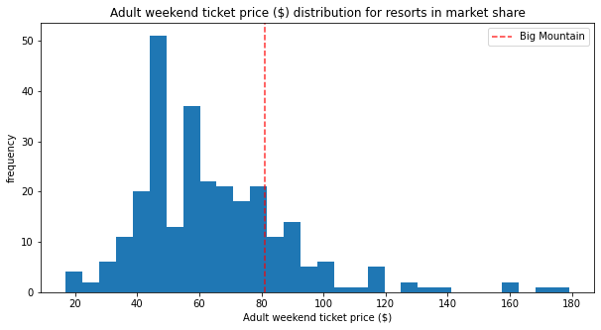Fig.1: Adult weekend ticket ($) distribution for resorts in market share.

From the histogram, it was obvious that the current ticket price must be adjusted. Even though the model predicted a price higher than the current one, the predicted price can be improved based on the facilities. During the price modelling, the following features came up as important to give an insight in the prediction; ‘vertical_drop’, ‘Snow Making_ac’, ‘total_chairs’, ‘fastQuads’, ‘Runs’, ‘LongestRun_mi’, ‘trams’ and ‘Skiable Terrain_ac’. A histogram distribution of these facilities owned by the resorts with an indication of where Big Mountain Resort sits, reveals that the resort was fairly high on almost all the league charts of the facilities except trams which it had none. Fig.2, shows Big Mountain Resort’s position in terms of vertical drop. The distribution was a factor in determining investment strategy because people pay more for certain facilities and less for others.

To have a better sense of how the facilities support ticket price, four scenarios were considered.

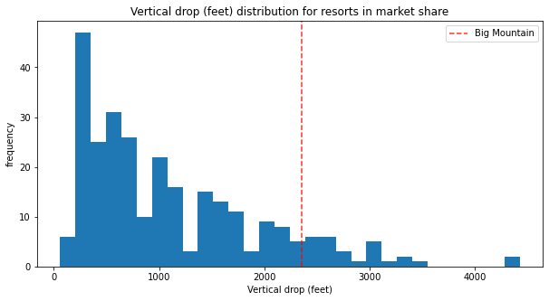

Fig.2: vertical drop (feet) distribution for resorts in market share

Scenario 1: closing 10 runs; Scenario 2: adding 1 runs, 150 feet vertical drop and 1 chair lift, Scenario 3: Scenario 2 + adding 2 snow making_ac and Scenario 4: adding 0.2 mile longest run and 4 snow making_ac. In the case of Scenario 1, there was no support for ticket price and revenue increase, some number of closures led to a big decrease in ticket price and revenue; and others resulted in no further loss.

Scenario 2 increases support for ticket price by $8.61 and an amount of $15,065,471. For Scenario 3, support for ticket price increased by $9.90 ($17,322,717). Scenario 4 made no difference.

Comparing Scenario 2 and 3, a small increase in the snow making area in Scenario 3 made minimal difference in the price. Hence, Scenario 2 was the optimum. Based on the model, it was therefore advisable for Big Mountain Resort to add a run, increase the vertical drop by 150 feets and install an additional chair lift.

Since the optimum Scenario increases ticket price by $8.61 and the price predicted before considering the Scenarios was $95.87, conclusion was drawn that a ticket price of $104.48 was what the model suggested for Big Mountain Resort based on the facilities. The prediction also occurred on the basis that the expected number of visitors over the season was 350,000 and, on average, visitors ski for five days.

Finally, considering the amount of revenue generated by the price delta (predicted price after scenarios – predicted price before scenarios) in Scenario 2, the predicted ticket price of $104.48 should generate enough revenue for Big Mountain Resort and also cover the operating cost ($1,540,000) of the additional chair lift installed for a season.